**Assange: Google Is Not What It Seems**

By [*Julian Assange*](http://www.newsweek.com/user/14479)

*Filed: 10/23/14 at 12:47 PM  | Updated: 10/24/14 at 5:38 PM*

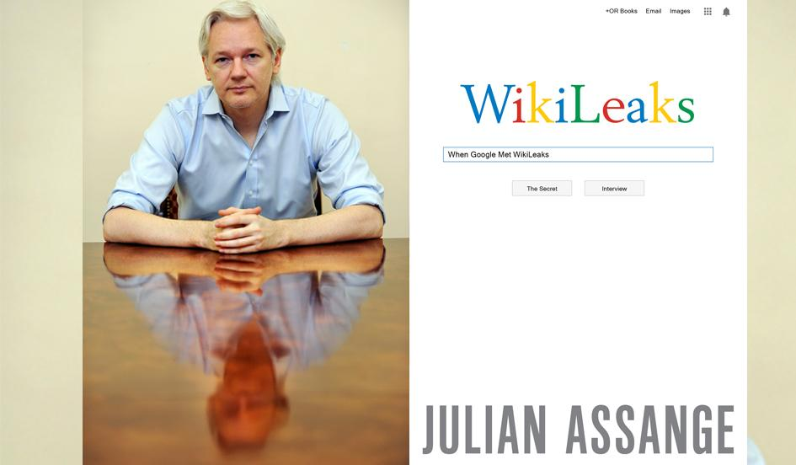

*"When Google Met Wikileaks" by Julian Assange published by OR Books. Reuters; OR Books*



**Tags:** [World](http://www.newsweek.com/world), [WikiLeaks](http://www.newsweek.com/topic/wikileaks), [Julian Assange](http://www.newsweek.com/topic/julian-assange), [Google](http://www.newsweek.com/topic/google), [Eric Schmidt](http://www.newsweek.com/topic/eric-schmidt), New America Foundation

*In June 2011, Julian Assange received an unusual visitor: the chairman of Google, Eric Schmidt, arrived from America at Ellingham Hall, the country house in Norfolk, England where Assange was living under house arrest.*

*For several hours the besieged leader of the world’s most famous insurgent publishing organization and the billionaire head of the world’s largest information empire locked horns. The two men debated the political problems faced by society, and the technological solutions engendered by the global network—from the Arab Spring to Bitcoin.*

*They outlined radically opposing perspectives: for Assange, the liberating power of the Internet is based on its freedom and statelessness. For Schmidt, emancipation is at one with U.S. foreign policy objectives and is driven by connecting non-Western countries to Western companies and markets. These differences embodied a tug-of-war over the Internet’s future that has only gathered force subsequently.*

[***Newsweek Magazine is Back In Print***](http://www.newsweek.com/trial)

*In this extract from*[When Google Met WikiLeaks](http://http/www.orbooks.com/catalog/when-google-met-wikileaks/) Assange*describes his encounter with Schmidt and how he came to conclude that it was far from an innocent exchange of views.*

Eric Schmidt is an influential figure, even among the parade of powerful characters with whom I have had to cross paths since I founded WikiLeaks. In mid-May 2011 I was under house arrest in rural Norfolk, England, about three hours’ drive northeast of London. The crackdown against our work was in full swing and every wasted moment seemed like an eternity. It was hard to get my attention.

But when my colleague Joseph Farrell told me the executive chairman of Google wanted to make an appointment with me, I was listening.

In some ways the higher echelons of Google seemed more distant and obscure to me than the halls of Washington. We had been locking horns with senior U.S. officials for years by that point. The mystique had worn off. But the power centers growing up in Silicon Valley were still opaque and I was suddenly conscious of an opportunity to understand and influence what was becoming the most influential company on earth. Schmidt had taken over as CEO of Google in 2001 and built it into an empire.

I was intrigued that the mountain would come to Muhammad. But it was not until well after Schmidt and his companions had been and gone that I came to understand who had really visited me.

The stated reason for the visit was a book. Schmidt was penning a treatise with Jared Cohen, the director of Google Ideas, an outfit that describes itself as Google’s in-house “think/do tank.”

I knew little else about Cohen at the time. In fact, Cohen had moved to Google from the U.S. State Department in 2010. He had been a fast-talking “Generation Y” ideas man at State under two U.S. administrations, a courtier from the world of policy think tanks and institutes, poached in his early twenties.

He became a senior advisor for Secretaries of State Rice and Clinton. At State, on the Policy Planning Staff, Cohen was soon christened “Condi’s party-starter,” channeling buzzwords from Silicon Valley into U.S. policy circles and producing delightful rhetorical concoctions such as “Public Diplomacy 2.0.” On his Council on Foreign Relations [adjunct staff page](http://archive.today/pkgQN) he listed his expertise as “terrorism; radicalization; impact of connection technologies on 21st century statecraft; Iran.”

It was Cohen who, while he was still at the Department of State, was said to have emailed Twitter CEO Jack Dorsey to delay scheduled maintenance in order to assist the aborted 2009 uprising in Iran. His documented love affair with Google began the same year when he befriended Eric Schmidt as they together surveyed the post-occupation wreckage of Baghdad. Just months later, Schmidt re-created Cohen’s natural habitat within Google itself by engineering a “think/do tank” based in New York and appointing Cohen as its head. Google Ideas was born.

Later that year two [co-wrote a policy piece](http://archive.today/R13l2) for the Council on Foreign Relations’ journal Foreign Affairs, praising the reformative potential of Silicon Valley technologies as an instrument of U.S. foreign policy. Describing what they called “coalitions of the connected,” Schmidt and Cohen claimed that:

*Democratic states that have built coalitions of their militaries have the capacity to do the same with their connection technologies.…*

*They offer a new way to exercise the****duty to protect****citizens around the world [emphasis added].*

Schmidt and Cohen said they wanted to interview me. I agreed. A date was set for June.

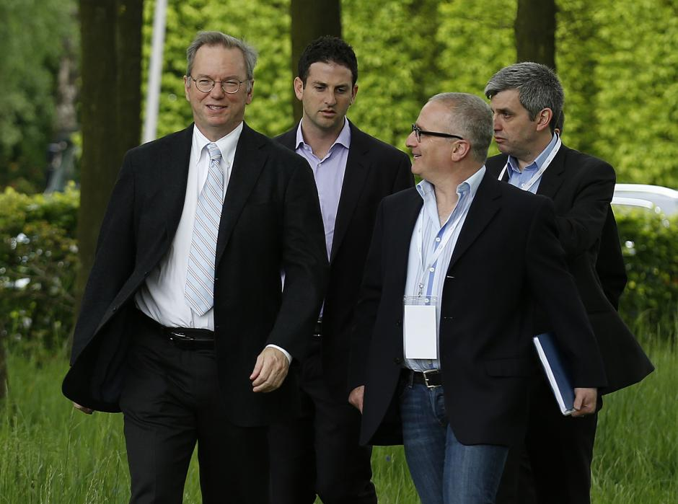*Executive Chairman of Google Eric Schmidt and Jared Cohen, director of Google Ideas Olivia Harris/Reuters*

\* \* \*

By the time June came around there was already a lot to talk about. That summer WikiLeaks was still grinding through the release of U.S. diplomatic cables, publishing thousands of them every week. When, seven months earlier, we had first started releasing the cables, Hillary Clinton [had denounced the publication](http://archive.today/AYRCx) as “an attack on the international community” that would “tear at the fabric” of government.

It was into this ferment that Google projected itself that June, touching down at a London airport and making the long drive up into East Anglia to Norfolk and Beccles.

Schmidt arrived first, accompanied by his then partner, Lisa Shields. When he introduced her as a vice president of the Council on Foreign Relations—a U.S. foreign-policy think tank with close ties to the State Department—I thought little more of it. Shields herself was straight out of Camelot, having been spotted by John Kennedy Jr.’s side back in the early 1990s.

They sat with me and we exchanged pleasantries. They said they had forgotten their Dictaphone, so we used mine. We made an agreement that I would forward them the recording and in exchange they would forward me the transcript, to be corrected for accuracy and clarity. We began. Schmidt plunged in at the deep end, straightaway quizzing me on the organizational and technological underpinnings of WikiLeaks.

\* \* \*

Some time later Jared Cohen arrived. With him was Scott Malcomson, introduced as the book’s editor. Three months after the meeting Malcomson would enter the State Department as the lead speechwriter and principal advisor to Susan Rice (then U.S. ambassador to the United Nations, now national security advisor).

At this point, the delegation was one part Google, three parts U.S. foreign-policy establishment, but I was still none the wiser. Handshakes out of the way, we got down to business.

Schmidt was a good foil. A late-fiftysomething, squint-eyed behind owlish spectacles, managerially dressed—Schmidt’s dour appearance concealed a machinelike analyticity. His questions often skipped to the heart of the matter, betraying a powerful nonverbal structural intelligence.

It was the same intellect that had abstracted software-engineering principles to scale Google into a megacorp, ensuring that the corporate infrastructure always met the rate of growth. This was a person who understood how to build and maintain systems: systems of information and systems of people. My world was new to him, but it was also a world of unfolding human processes, scale and information flows.

For a man of systematic intelligence, Schmidt’s politics—such as I could hear from our discussion—were surprisingly conventional, even banal. He grasped structural relationships quickly, but struggled to verbalize many of them, often shoehorning geopolitical subtleties into Silicon Valley marketese or the ossified State Department micro-language of his companions. He was at his best when he was speaking (perhaps without realizing it) as an engineer, breaking down complexities into their orthogonal components.

I found Cohen a good listener, but a less interesting thinker, possessed of that relentless conviviality that routinely afflicts career generalists and Rhodes Scholars. As you would expect from his foreign-policy background, Cohen had a knowledge of international flash points and conflicts and moved rapidly between them, detailing different scenarios to test my assertions. But it sometimes felt as if he was riffing on orthodoxies in a way that was designed to impress his former colleagues in official Washington.

Malcomson, older, was more pensive, his input thoughtful and generous. Shields was quiet for much of the conversation, taking notes, humoring the bigger egos around the table while she got on with the real work.

As the interviewee, I was expected to do most of the talking. I sought to guide them into my worldview. To their credit, I consider the interview perhaps the best I have given. I was out of my comfort zone and I liked it.

We ate and then took a walk in the grounds, all the while on the record. I asked Eric Schmidt to leak U.S. government information requests to WikiLeaks, and he refused, suddenly nervous, citing the illegality of disclosing Patriot Act requests. And then, as the evening came on, it was done and they were gone, back to the unreal, remote halls of information empire, and I was left to get back to my work.

**That was the end of it, or so I thought.**

\* \* \*

Two months later, WikiLeaks’ release of State Department cables was coming to an abrupt end. For three-quarters of a year we had painstakingly managed the publication, pulling in over a hundred global media partners, distributing documents in their regions of influence and overseeing a worldwide, systematic publication and redaction system, fighting for maximum impact for our sources.

But *The Guardian* newspaper—our former partner—had published the confidential decryption password to all 251,000 cables in a chapter heading in its book, [rushed out hastily](http://archive.today/5KLJH) in February 2011.

By mid-August we discovered that a former German employee—whom I had suspended in 2010—was cultivating business relationships with a variety of organizations and individuals by shopping around the location of the encrypted file, paired with the password’s whereabouts in the book. At the rate the information was spreading, we estimated that within two weeks most intelligence agencies, contractors and middlemen would have all the cables, but the public would not.

I decided it was necessary to bring forward our publication schedule by four months and contact the State Department to get it on record that we had given them advance warning. The situation would then be harder to spin into another legal or political assault.

Unable to raise Louis Susman, then U.S. ambassador to the U.K., we tried the front door. WikiLeaks investigations editor Sarah Harrison called the State Department front desk and informed the operator that “Julian Assange” wanted to have a conversation with Hillary Clinton. Predictably, this statement was initially greeted with bureaucratic disbelief.

We soon found ourselves in a reenactment of that scene in Dr. Strangelove, where Peter Sellers cold-calls the White House to warn of an impending nuclear war and is immediately put on hold. As in the film, we climbed the hierarchy, speaking to incrementally more superior officials until we reached Clinton’s senior legal advisor. He told us he would call us back. We hung up, and waited.

When the phone rang half an hour later, it was not the State Department on the other end of the line. Instead, it was Joseph Farrell, the WikiLeaks staffer who had set up the meeting with Google. He had just received an email from Lisa Shields seeking to confirm that it was indeed WikiLeaks calling the State Department.

It was at this point that I realized Eric Schmidt might not have been an emissary of Google alone. Whether officially or not, he had been keeping some company that placed him very close to Washington, D.C., including a well-documented relationship with President Obama. Not only had Hillary Clinton’s people known that Eric Schmidt’s partner had visited me, but they had also elected to use her as a back channel.

While WikiLeaks had been deeply involved in publishing the inner archive of the U.S. State Department, the U.S. State Department had, in effect, snuck into the WikiLeaks command center and hit me up for a free lunch. Two years later, in the wake of his early 2013 visits to China, North Korea and Burma, it would come to be appreciated that the chairman of Google might be conducting, in one way or another, “back-channel diplomacy” for Washington. But at the time [it was a novel thought](http://archive.today/bXrQ2).

I put it aside until February 2012, when WikiLeaks—along with over thirty of our international media partners—began publishing the Global Intelligence Files: the internal email spool from the Texas-based private intelligence firm Stratfor. One of our stronger investigative partners—the Beirut-based newspaper Al Akhbar— [scoured the emails for intelligence](http://archive.today/gHMzq) on Jared Cohen.

The people at Stratfor, who liked to think of themselves as a sort of corporate CIA, were acutely conscious of other ventures that they perceived as making inroads into their sector. Google had turned up on their radar. In a series of colorful emails they discussed a pattern of activity conducted by Cohen under the Google Ideas aegis, suggesting what the “do” in “think/do tank” actually means.

Cohen’s directorate appeared to cross over from public relations and “corporate responsibility” work into active corporate intervention in foreign affairs at a level that is normally reserved for states. Jared Cohen could be wryly named Google’s “director of regime change.”

According to the emails, he was trying to plant his fingerprints on some of the major historical events in the contemporary Middle East. He could be placed in Egypt during the revolution, meeting with Wael Ghonim, the Google employee whose arrest and imprisonment hours later would make him a PR-friendly symbol of the uprising in the Western press. Meetings had been planned in Palestine and Turkey, both of which—claimed Stratfor emails—were killed by the senior Google leadership as too risky.

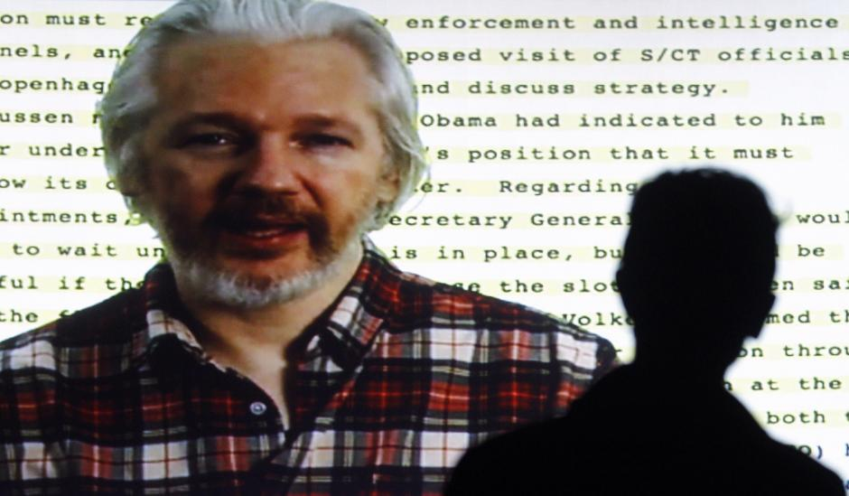*Founder of Wikileaks Julian Assange speaking from the Ecuadorean embassy in London appears on a screen as he gives a video conference to open the Human Rights Film Festival in Barcelona on October 22, 2014. Quique Garcia/AFP/Getty*

Only a few months before he met with me, Cohen was planning a trip to the edge of Iran in Azerbaijan to “engage the Iranian communities closer to the border,” as part of a Google Ideas’ project on “repressive societies.” In internal emails Stratfor’s vice president for intelligence, Fred Burton (himself a former State Department security official), [wrote](http://archive.today/sjxuG):

*Google is getting WH [White House] and State Dept support and air cover. In reality they are doing things the CIA cannot do…*

*[Cohen] is going to get himself kidnapped or killed. Might be the best thing to happen to expose Google’s covert role in foaming up-risings, to be blunt. The US Gov’t can then disavow knowledge and Google is left holding the shit-bag.*

In [further internal communication](http://archive.today/IoFw4), Burton said his sources on Cohen’s activities were Marty Lev—Google’s director of security and safety—and Eric Schmidt himself.

Looking for something more concrete, I began to search in WikiLeaks’ archive for information on Cohen. [State Department cables](http://archive.today/loAlC) released as part of Cablegate reveal that Cohen had been in Afghanistan in 2009, trying to convince the four major Afghan mobile phone companies to move their antennas onto U.S. military bases. In Lebanon, he quietly [worked to establish](http://archive.today/34MyI) an intellectual and clerical rival to Hezbollah, the “Higher Shia League.” And in London [he offered Bollywood movie executives](http://archive.today/mxXGQ) funds to insert anti-extremist content into their films, and promised to connect them to related networks in Hollywood.

Three days after he visited me at Ellingham Hall, Jared Cohen flew to Ireland to direct the “[Save Summit](http://archive.today/rA1tA),” an event co-sponsored by Google Ideas and the Council on Foreign Relations. Gathering former inner-city gang members, right-wing militants, violent nationalists and “religious extremists” from all over the world together in one place, the event aimed to workshop technological solutions to the problem of “violent extremism.” What could go wrong?

Cohen’s world seems to be one event like this after another: endless soirees for the cross-fertilization of influence between elites and their vassals, under the pious rubric of “civil society.” The received wisdom in advanced capitalist societies is that there still exists an organic “civil society sector” in which institutions form autonomously and come together to manifest the interests and will of citizens. The fable has it that the boundaries of this sector are respected by actors from government and the “private sector,” leaving a safe space for NGOs and nonprofits to advocate for things like human rights, free speech and accountable government.

This sounds like a great idea. But if it was ever true, it has not been for decades. Since at least the 1970s, authentic actors like unions and churches have folded under a sustained assault by free-market statism, transforming “civil society” into a buyer’s market for political factions and corporate interests looking to exert influence at arm’s length. The last forty years have seen a huge proliferation of think tanks and political NGOs whose purpose, beneath all the verbiage, is to execute political agendas by proxy.

It is not just obvious neocon front groups like Foreign Policy Initiative. It also includes fatuous Western NGOs like Freedom House, where naïve but well-meaning career nonprofit workers are twisted in knots by political funding streams, denouncing non-Western human rights violations while keeping local abuses firmly in their blind spots.

The civil society conference circuit—which flies developing-world activists across the globe hundreds of times a year to bless the unholy union between “government and private stakeholders” at geopoliticized events like the “Stockholm Internet Forum”—simply could not exist if it were not blasted with millions of dollars in political funding annually.

Scan the memberships of the biggest U.S. think tanks and institutes and the same names keep cropping up. Cohen’s Save Summit went on to seed AVE, or AgainstViolentExtremism.org, a long-term project whose principal backer besides Google Ideas is the Gen Next Foundation. This [foundation’s website](http://archive.today/p91bd) says it is an “exclusive membership organization and platform for successful individuals” that aims to bring about “social change” driven by venture capital funding. Gen Next’s “private sector and non-profit foundation support avoids some of the potential perceived conflicts of interest faced by initiatives funded by governments.” Jared Cohen is an executive member.

Gen Next also backs [an NGO](http://archive.today/oVlqH), launched by Cohen toward the end of his State Department tenure, for bringing Internet-based global “pro-democracy activists” into the U.S. foreign relations patronage network. The group originated as the “Alliance of Youth Movements” with an inaugural summit in New York City in 2008 funded by the State Department and encrusted with the logos of [corporate sponsors](http://archive.today/DQo19). The summit flew in carefully selected [social media activists](http://is.gd/bLOVxT) from “problem areas” like Venezuela and Cuba to watch speeches by the Obama campaign’s new-media team and the State Department’s James Glassman, and to network with public relations consultants, “philanthropists,” and U.S. media personalities.

The outfit held two more invite-only summits in London and Mexico City where the delegates were [directly addressed via video link](http://archive.today/I2x6U) by Hillary Clinton:

*You are the vanguard of a rising generation of citizen activists.…*

*And that makes you the kind of leaders we need.*

In 2011, the Alliance of Youth Movements rebranded as “Movements.org.” In 2012 Movements.org became a division of “Advancing Human Rights,”[a new NGO](http://archive.today/jqq9U) set up by Robert L. Bernstein after he resigned from Human Rights Watch (which he had originally founded) because he felt it should not cover Israeli and U.S. human rights abuses. Advancing Human Rights aims to right Human Rights Watch’s wrong by [focusing exclusively](http://archive.today/kBzYe) on “dictatorships.”

Cohen stated that the merger of his Movements.org outfit with Advancing Human Rights was “irresistible,” pointing to the latter’s “phenomenal network of cyber-activists in the Middle East and North Africa.” He then joined the [Advancing Human Rights board](http://archive.today/pXmPk), which also includes Richard Kemp, the former commander of British forces in occupied Afghanistan. In its present guise, Movements.org continues to receive funding from Gen Next, as well as from Google, MSNBC and PR giant Edelman, which represents General Electric, Boeing, and Shell, among others.

Google Ideas is bigger, but it follows the same game plan. Glance down the speaker lists of its annual invite-only get-togethers, such as “Crisis in a Connected World” in October 2013. Social network theorists and activists give the event a veneer of authenticity, but in truth it boasts a toxic piñata of attendees: U.S. officials, telecom magnates, security consultants, finance capitalists and foreign-policy tech vultures like Alec Ross (Cohen’s twin at the State Department).

At the hard core are the arms contractors and career military: active U.S. Cyber Command chieftains, and even the admiral responsible for all U.S. military operations in Latin America from 2006 to 2009. [Tying up the package](http://archive.today/Ed8rA) are **Jared Cohen and the chairman of Google, Eric Schmidt**.

I began to think of Schmidt as a brilliant but politically hapless Californian tech billionaire who had been exploited by the very U.S. foreign-policy types he had collected to act as translators between himself and official Washington—a West Coast–East Coast illustration of the principal-agent dilemma.

I was wrong.

\* \* \*

Eric Schmidt was born in Washington, D.C., where his father had worked as a professor and economist for the Nixon Treasury. He attended high school in Arlington, Virginia, before graduating with a degree in engineering from Princeton.

In 1979, Schmidt headed out West to Berkeley, where he received his Ph.D. before joining Stanford/ Berkeley spin-off Sun Microsystems in 1983. By the time he left Sun, sixteen years later, he had become part of its executive leadership.

Sun had significant contracts with the U.S. government, but it was not until he was in Utah as CEO of Novell that records show Schmidt strategically engaging Washington’s overt political class. Federal campaign finance records show that on January 6, 1999, Schmidt donated two lots of $1,000 to the Republican senator for Utah, Orrin Hatch. On the same day Schmidt’s wife, Wendy, is also listed giving two lots of $1,000 to Senator Hatch.

By the start of 2001, over a dozen other politicians and PACs, including Al Gore, George W. Bush, Dianne Feinstein, and Hillary Clinton, were on the Schmidts’ payroll, in one case for $100,000.

By 2013, Eric Schmidt—who had become publicly over-associated with the Obama White House—was more politic. Eight Republicans and eight Democrats were directly funded, as were two PACs. That April, $32,300 went to the National Republican Senatorial Committee. A month later the same amount, $32,300, headed off to the Democratic Senatorial Campaign Committee. Why Schmidt was donating exactly the [same amount of money to both parties](http://archive.today/yjXoi) is a $64,600 question.

It was also in 1999 that Schmidt joined the board of a Washington, D.C.–based group: the New America Foundation, a merger of well-connected centrist forces (in D.C. terms). The foundation and its 100 staff serve as an influence mill, using its network of approved national security, foreign policy and technology pundits to place hundreds of articles and op-eds per year.

By 2008, Schmidt had become chairman of its board of directors. As of 2013 the [New America Foundation’s principal funders](http://archive.today/3FnFm) (each contributing over $1 million) were listed as Eric and Wendy Schmidt, the U.S. State Department and the Bill & Melinda Gates Foundation. Secondary funders include Google, the United States Agency for International Development (USAID) and Radio Free Asia.

Schmidt’s involvement in the New America Foundation places him firmly in the Washington establishment nexus. The foundation’s [other board members](http://archive.today/iBvgl), seven of whom also list themselves as members of the Council on Foreign Relations, include Francis Fukuyama, one of the intellectual fathers of the neoconservative movement; Rita Hauser, who served on the President’s Intelligence Advisory Board under both Bush and Obama; Jonathan Soros, the son of George Soros; Walter Russell Mead, a U.S. security strategist and editor of the American Interest; Helene Gayle, who sits on the boards of Coca-Cola, Colgate-Palmolive, the Rockefeller Foundation, the State Department’s Foreign Affairs Policy Unit, the Council on Foreign Relations, the Center for Strategic and International Studies, the White House Fellows program and Bono’s ONE Campaign; and Daniel Yergin, oil geo-strategist, former chair of the U.S. Department of Energy’s Task Force.

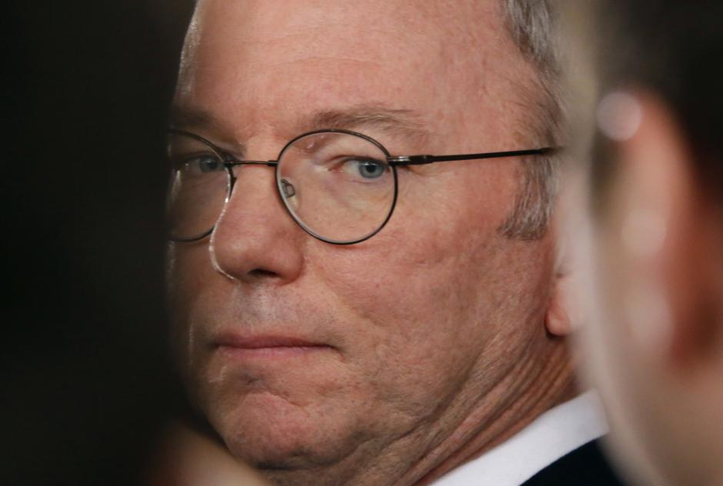*Google Executive Chairman Eric Schmidt Petar Kujundzic/Reuters*

The chief executive of the foundation, appointed in 2013, is Jared Cohen’s former boss at the State Department’s Policy Planning Staff, [Anne-Marie Slaughter](http://archive.today/yIoLP), a Princeton law and international relations wonk with an eye for revolving doors. She is everywhere, [issuing calls](http://archive.today/GiLng) for Obama to respond to the Ukraine crisis not only by deploying covert U.S. forces into the country but also by dropping bombs on Syria—on the basis that this will send a message to Russia and China. Along with Schmidt, she is a 2013 attendee of the Bilderberg conference and sits on the State Department’s [Foreign Affairs Policy Board](http://archive.today/Why8v).

There was nothing politically hapless about Eric Schmidt. I had been too eager to see a politically unambitious Silicon Valley engineer, a relic of the good old days of computer science graduate culture on the West Coast. But that is not the sort of person who [attends the Bilderberg conference](http://archive.today/pUY5b) four years running, who pays regular visits to the White House, or who delivers “fireside chats” at the World Economic Forum in Davos.

Schmidt’s emergence as Google’s “foreign minister”—making pomp and ceremony state visits across geopolitical fault lines—had not come out of nowhere; it had been presaged by years of assimilation within U.S. establishment networks of reputation and influence.

On a personal level, Schmidt and Cohen are perfectly likable people. But Google’s chairman is a classic “head of industry” player, with all of the [ideological baggage](http://archive.today/gZepE) that comes with that role. Schmidt fits exactly where he is: **the point where the centrist, liberal and imperialist tendencies meet in American political life**.

By all appearances, Google’s bosses genuinely believe in the civilizing power of enlightened multinational corporations, and they see this mission as continuous with the shaping of the world according to the better judgment of the “benevolent superpower.” They will tell you that open-mindedness is a virtue, but all perspectives that challenge the exceptionalist drive at the heart of American foreign policy will remain invisible to them. This is the impenetrable banality of “don’t be evil.” They believe that they are doing good. And that is a problem.

\* \* \*

Google is different. Google is visionary. Google is the future. Google is more than just a company. Google gives back to the community. Google is a force for good.

Even when Google [airs its corporate ambivalence publicly](http://archive.today/rwyQ7), it does little to dislodge these items of faith. The company’s reputation is seemingly unassailable. Google’s colorful, playful logo is imprinted on human retinas just [under 6 billion times each day](http://archive.today/W7DgX), 2.1 trillion times a year—an opportunity for respondent conditioning enjoyed by no other company in history.

Caught red-handed last year making petabytes of personal data available to the U.S. intelligence community through the PRISM program, Google nevertheless continues to coast on the goodwill generated by its “don’t be evil” doublespeak. A few symbolic open letters to the White House later and it seems all is forgiven. Even anti-surveillance campaigners cannot help themselves, at once condemning government spying but trying to alter Google’s invasive surveillance practices using appeasement strategies.

Nobody wants to acknowledge that Google has grown big and bad. But it has. Schmidt’s tenure as CEO saw Google integrate with the shadiest of U.S. power structures as it expanded into a geographically invasive megacorporation. But Google has always been comfortable with this proximity. Long before company founders Larry Page and Sergey Brin hired Schmidt in 2001, their initial research upon which Google was based [had been partly funded](http://archive.today/tb5VL) by the Defense Advanced Research Projects Agency (DARPA). And even as Schmidt’s Google developed an image as the overly friendly giant of global tech, it was building a close relationship with the intelligence community.

In 2003, the U.S. National Security Agency (NSA) had already started systematically violating the Foreign Intelligence Surveillance Act (FISA) under its director General Michael Hayden. These were the days of the “Total Information Awareness” program. Before PRISM was ever dreamed of, under orders from the Bush White House the NSA was already aiming to “collect it all, sniff it all, know it all, process it all, exploit it all.”

During the same period, Google—whose publicly declared [corporate mission](http://archive.today/JavDC) is to collect and “organize the world’s information and make it universally accessible and useful”—[was accepting NSA money](http://bit.ly/1qNoHQ9) to the tune of $2 million to provide the agency with search tools for its rapidly accreting hoard of stolen knowledge.

In 2004, after taking over Keyhole, a mapping tech startup co-funded by the National Geospatial-Intelligence Agency (NGA) and the CIA, Google developed the technology into Google Maps, an enterprise version of which it has since shopped to the Pentagon and associated federal and state agencies on multimillion-dollar [contracts](http://archive.today/W35WU).

In 2008, Google helped launch an NGA spy satellite, the GeoEye-1, into space. Google shares the photographs from the satellite with the U.S. military and intelligence communities. In 2010, NGA awarded Google a [$27 million contract](http://archive.today/W35WU) for “geospatial visualization services.”

In 2010, after the Chinese government was accused of hacking Google, the company entered into a “formal information-sharing” relationship with the NSA, which was said to [allow NSA analysts](http://archive.today/hVTVl) to “evaluate vulnerabilities” in Google’s hardware and software. Although the exact contours of the deal have never been disclosed, the NSA brought in other government agencies to help, including the FBI and the Department of Homeland Security.

Around the same time, Google was becoming involved in a program known as the “Enduring Security Framework” (ESF), which entailed the sharing of information between Silicon Valley tech companies and Pentagon-affiliated agencies “at network speed.” Emails obtained in 2014 under Freedom of Information requests show Schmidt and his fellow Googler Sergey Brin corresponding on first-name terms with NSA chief General Keith Alexander about ESF.

Reportage on the emails focused on the familiarity in the correspondence: “General Keith…so great to see you…!” Schmidt wrote. But most reports over-looked a crucial detail. “Your insights as a key member of **the Defense Industrial Base**,” Alexander wrote to Brin, “are valuable to ensure ESF’s efforts have measurable impact.”

*The Department of Homeland Security*[*defines the Defense Industrial Base*](http://archive.today/Y7Z23)*as “the worldwide industrial complex that enables research and development, as well as design, production, delivery, and maintenance of military weapons systems, subsystems, and components or parts, to meet****U.S. military requirements****[emphasis added].” The Defense Industrial Base provides “products and services that are essential to mobilize, deploy, and sustain military operations.”*

Does it include regular commercial services purchased by the U.S. military? No. The definition specifically excludes the purchase of regular commercial services. Whatever makes Google a “key member of the Defense Industrial Base,” it is not recruitment campaigns pushed out through Google AdWords or soldiers checking their Gmail.

In 2012, Google arrived on the [list of top-spending Washington, D.C., lobbyists](http://archive.today/xQyui)—a list typically stalked exclusively by the U.S. Chamber of Commerce, military contractors, and the petro-carbon leviathans. Google entered the rankings above military aerospace giant Lockheed Martin, with a total of $18.2 million spent in 2012 to Lockheed’s $15.3 million. Boeing, the military contractor that absorbed McDonnell Douglas in 1997, also came below Google, at $15.6 million spent, as did Northrop Grumman at $17.5 million.

In autumn 2013 the Obama administration was trying to drum up support for U.S. airstrikes against Syria. Despite setbacks, the administration [continued to press for military action](http://archive.today/THPGh) well into September with speeches and public announcements by both President Obama and Secretary of State John Kerry. On September 10, Google lent its front page—the most popular on the Internet—to the war effort, [inserting a line below the search box](http://archive.today/Q6uq8) reading “Live! Secretary Kerry answers questions on Syria. Today via Hangout at 2pm ET.”

As the self-described “radical centrist” *New York Times* columnist Tom Friedman [wrote in 1999](http://archive.today/aQHvy), sometimes it is not enough to leave the global dominance of American tech corporations to something as mercurial as “the free market”:

*The hidden hand of the market will never work without a hidden fist. McDonald’s cannot flourish without McDonnell Douglas, the designer of the F-15. And the hidden fist that keeps the world safe for Silicon Valley’s technologies to flourish is called the U.S. Army, Air Force, Navy and Marine Corps.*

If anything has changed since those words were written, it is that Silicon Valley has grown restless with that passive role, aspiring instead to adorn the hidden fist like a velvet glove. Writing in 2013, Schmidt and Cohen stated,

*What Lockheed Martin was to the twentieth century, technology and cyber-security companies will be to the twenty-first.*

One way of looking at it is that it’s just business. For an American Internet services monopoly to ensure global market dominance, it cannot simply keep doing what it is doing and let politics take care of itself. American strategic and economic hegemony becomes a vital pillar of its market dominance. What’s a megacorp to do? If it wants to straddle the world, it must become part of the original “don’t be evil” empire.

But part of the resilient image of Google as “more than just a company” comes from the perception that it does not act like a big, bad corporation. Its penchant for luring people into its services trap with gigabytes of “free storage” produces the perception that Google is giving it away for free, acting directly contrary to the corporate profit motive.

Google is perceived as an essentially philanthropic enterprise—a magical engine presided over by otherworldly visionaries—for creating a [utopian future](http://archive.today/kHYcB). The company has at times appeared anxious to cultivate this image, pouring funding into “corporate responsibility” initiatives to produce “social change”—exemplified by Google Ideas.

But as Google Ideas shows, the company’s “philanthropic” efforts, too, bring it uncomfortably close to the imperial side of U.S. influence. If Blackwater/Xe Services/Academi was running a program like Google Ideas, it would draw intense critical scrutiny. But **somehow Google gets a free pass**.

Whether it is being just a company or “more than just a company,” Google’s geopolitical aspirations are firmly enmeshed within the foreign-policy agenda of the world’s largest superpower. As Google’s search and Internet service monopoly grows, and as it enlarges its industrial surveillance cone to cover the majority of the world’s population, [rapidly dominating the mobile phone market and racing to extend Internet access in the global south](http://archive.today/cTeRY), Google is steadily becoming the Internet for many people. Its influence on the choices and behavior of the totality of individual human beings translates to real power to influence the course of history.

If the future of the Internet is to be Google, that should be of serious concern to people all over the world—in Latin America, East and Southeast Asia, the Indian subcontinent, the Middle East, sub-Saharan Africa, the former Soviet Union and [even in Europe](http://archive.today/LTL6l)—for whom the Internet embodies the promise of an alternative to U.S. cultural, economic, and strategic hegemony.

A “don’t be evil” empire is still an empire.

*Extracted from*[*When Google Met Wikileaks by Julian Assange*](http://www.orbooks.com/catalog/when-google-met-wikileaks/?utm_source=newsweek&utm_medium=serial&utm_campaign=google_met_wikileaks)*published by [OR Books](http://www.orbooks.com/catalog/when-google-met-wikileaks/?utm_source=newsweek&utm_medium=serial&utm_campaign=google_met_wikileaks" \t "_blank).*Newsweek *readers can obtain a 20 percent discount on the cover price when ordering from the*[*OR Books website*](http://www.orbooks.com/catalog/when-google-met-wikileaks/?utm_source=newsweek&utm_medium=serial&utm_campaign=google_met_wikileaks)*and including the offer code word NEWSWEEK.*